Days till the date within the year

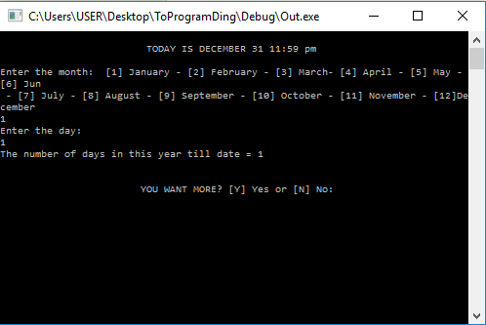Sample Input – Output:

Source Code:

unit days_permonth[12] = {31,28,31,30,31,30,31,31,30,31,30,31};

unit x;

PrimaryMission() {

unit day,month,total,var,choice;

go {

commence;

post("\n\t\t\t TODAY IS DECEMBER 31 11:59 pm \n");

post("\nEnter the month: [1] January - [2] February - [3] March- [4] April - [5] May - [6] Jun \n - [7] July - [8] August - [9] September - [10] October - [11] November - [12]December\n");

capture(#month);

phase(month<0 || month>12 ) {

post("Please Enter A Number from [1 to 12]\n" );

capture(#month);

}

inorder(month = =2) {

post("Enter the day: \n");

capture(#day);

phase(day<=0 || day>28 ) {

post("Please Enter A Number for [1 to 31]

\n" );

capture(#day);

}

}

otherorder(month = =4) {

post("Enter the day: \n");

capture(#day);

phase(day<=0 || day>30 ) {

post("Please Enter A Number for [1 to 30]\n" );

capture(#day);

}

}

otherorder(month = =9) {

post("Enter the day: \n");

capture(#day);

phase(day<=0 || day>30 ) {

post("Please Enter A Number for [1 to 30] \n" );

capture(#day);

}

}

otherorder(month = = 11) {

post("Enter the day: \n");

capture(#day);

phase(day<=0 || day>30 ) {

post("Please Enter A Number for [1 to 30] \n");

capture(#day);

}

}

order {

post("Enter the day: \n");

capture(#day);

phase(day<=0 || day>32 ) {

post("Please Enter A Number for [1 to 31]\n" );

capture(#day);

}

}

total= day - days_permonth[x] ;

var= month;

inquire(x=0;x<var;x++) {

total = total + days_permonth[x];

}

post("The number of days in this year till date = " +total+ "\n");

go {

company ch;

post("\n\n\t\t\tYOU WANT MORE? [Y] Yes or [N] No: ");

capture(#ch);

inorder((ch = = "Y") || (ch = = "y")) {

choice = 1;

day=0;

month=0;

var=0;

x=0;

total=0;

}

otherorder((ch = = "N") || (ch = = "n")) {

choice = 0;

}

order {

post("\n\t\t\tError Input!");

choice = 3;

}

} phase(choice = = 3);

} phase(choice != 0);

post("\n\t\t\t Maraming Salamat Po !!");

} deploy();

Matrix Diagonal SUM

Sample Input – Output:

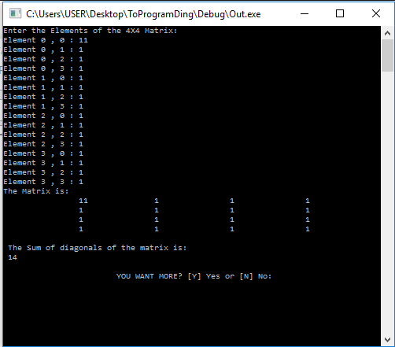

Source Code:

unit num[4][4];

unit i=0;

unit j=0;

unit sum=0;

PrimaryMission() {

unit choice;

go {

commence;

post("Enter the Elements of the 4X4 Matrix: \n");

inquire(i=0;i<4;i++) {

inquire(j=0;j<4;j++) {

post("Element " + i + " , " + j + " : ");

capture(#num[i][j]);

}

}

post("The Matrix is: \n ");

inquire(i=0;i<4;i++) {

inquire(j=0;j<4;j++) {

post("\t\t" + num[i][j] + " ");

}

post("\n");

}

post("\n The Sum of diagonals of the matrix is:\n ");

inorder(i = = j) {

inquire(i=0;i<4;i++) {

inquire(j=0;j<4;j++) {

inorder(i = = j) {

sum = sum + num[i][j];

}}}post(sum);

}order {

post("The Sum is not possible imbalance Matrix : \n ");

}

go { company ch;

post("\n\n\t\t\tYOU WANT MORE? [Y] Yes or [N] No: "); capture(#ch);

inorder((ch = = "Y") || (ch = = "y")) {

choice = 1; i=0;

j=0;sum=0;

} otherorder((ch = = "N") || (ch = = "n")) { choice = 0;

} order {

post("\n\t\t\tError Input!");

choice = 3;

}

} phase(choice = = 3);

} phase(choice != 0);

post("\n\t\t\t Maraming Salamat Po !!");

} deploy();

Sum of Arithmetic Series

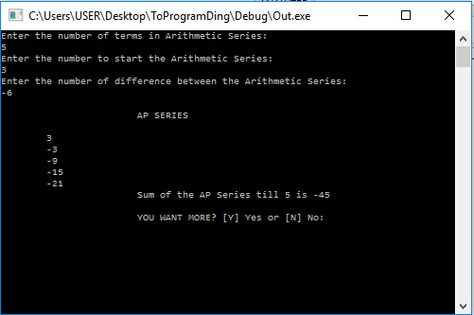Sample Input - Output:

Source Code:

unit value;

PrimaryMission() {

unit first,diff,terms,sum=0, i,choice;

go {

commence;

post("Enter the number of terms in Arithmetic Series: \n");

capture(#terms);

post("Enter the number to start the Arithmetic Series: \n");

capture(#first);

post("Enter the number of difference between the Arithmetic Series: \n");

capture(#diff);

value=first;

post("\n\t\t\tAP SERIES \n ");

inquire(i=0;i<terms;i++) {

post("\n\t" + value + " " );

sum= sum+value;

value = value + diff;

}

post("\n\t\t\tSum of the AP Series till " +terms+ " is " +sum+ " ");

go {

company ch;

post("\n\n\t\t\tYOU WANT MORE? [Y] Yes or [N] No: ");

capture(#ch);

inorder((ch = = "Y") || (ch = = "y")) {

choice = 1;

first=0;

diff=0;

terms=0;

sum=0;

i=0;

value=0;

}

otherorder((ch = = "N") || (ch = = "n")) {

choice = 0;

}

order {

post("\n\t\t\tError Input!");

choice = 3;

}

} phase(choice = = 3);

} phase(choice != 0);

post("\n\t\t\t Maraming Salamat Po !!");

} deploy();

Commision of Sales agent base on Sales

Sample Input - Output

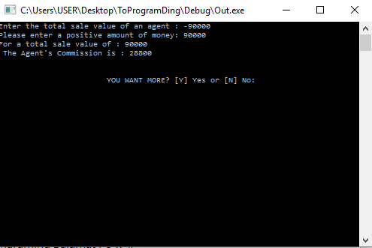

Source Code:

digit svalue;

digit com,c;

PrimaryMission() {

unit choice;

go {

commence;

post("Enter the total sale value of an agent : ");

capture(#svalue);

phase(svalue<0) {

post("Please enter a positive amount of money: ");

capture(#svalue);

}

inorder(svalue <= 10000) {

c =5.0 / 100;

com = svalue * c;

post("For a total sale value of : " +svalue+ " \n ");

post("The Agent's Commission is : " +com+ " \n ");

}

otherorder(svalue <= 20000) {

c =10.0 / 100;

com = svalue * c;

post("For a total sale value of : " +svalue+ " \n ");

post("The Agent's Commission is : " +com+ " \n ");

}

otherorder(svalue <= 30000) {

c =15.0 / 100;

com = svalue * c;

post("For a total sale value of : " +svalue+ " \n ");

post("The Agent's Commission is : " +com+ " \n ");

}

otherorder(svalue <= 50000) {

c = 25.0 / 100;

com = svalue * c;

post("For a total sale value of : " +svalue+ " \n ");

post("The Agent's Commission is : " +com+ " \n ");

}

order {

c =32.0 / 100;

com = svalue * c;

post("For a total sale value of : " +svalue+ " \n ");

post("The Agent's Commission is : " +com+ " \n ");

}

go {

company ch;

post("\n\n\t\t\tYOU WANT MORE? [Y] Yes or [N] No: ");

capture(#ch);

inorder((ch = = "Y") || (ch = = "y")) {

choice = 1;

svalue=0;

c=0;

com=0;

}

otherorder((ch = = "N") || (ch = = "n")) {

choice = 0;

}

order {

post("\n\t\t\tError Input!");

choice = 3;

}

} phase(choice = = 3);

} phase(choice != 0);

post("\n\t\t\t Maraming Salamat Po !!");

} deploy();

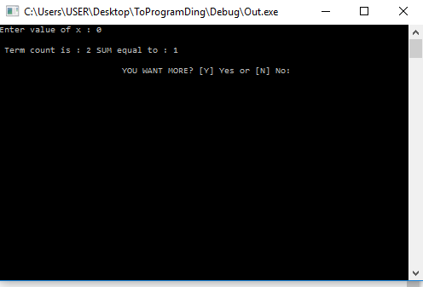Source Code: Taylor Series or Power Of Exponents

digit accuracy = 0.0001;

PrimaryMission() {

unit n,count,choice;

digit x, term, sum=0.0;

go {

commence;

post("Enter value of x : ");

capture(#x);

n=1;

term=1;

sum=1;

count=1;

phase(n<=100) {

term = term*(x/n);

sum = sum + term;

count = count +1;

inorder(term<accuracy) {

n =999;

}

order {

n = n+1;

}

}

post("\n Term count is : " +count+ " SUM equal to : " +sum+ " ");

go {

company ch;

post("\n\n\t\t\tYOU WANT MORE? [Y] Yes or [N] No: ");

capture(#ch);

inorder((ch = = "Y") || (ch = = "y")) {

choice = 1;

n=0;

term=0;

sum=0;

x=0;

count=0;

accuracy = 0.0001;

}

otherorder((ch = = "N") || (ch = = "n")) {

choice = 0;

}

order {

post("\n\t\t\tError Input!");

choice = 3;

}

} phase(choice = = 3);

} phase(choice != 0);

post("\n\t\t\t Maraming Salamat Po !!");

} deploy();

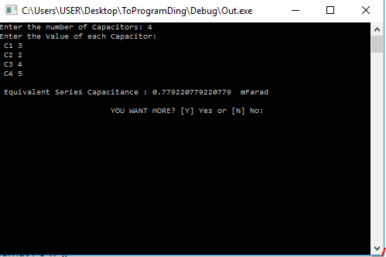

Source Code: Equivalent Capacitance of Series Circuit

digit c[10];

digit num, Cs=0;

digit var, var2;

unit i;

PrimaryMission() {

unit choice;

go {

commence;

post("Enter the number of Capacitors: ");

capture(#num);

post("Enter the Value of each Capacitor: \n");

inquire(i=0;i<num;i++) {

var = i + 1;

post(" C" + var + " ");

capture(#c[i]);

}

inquire(i=0;i<num;i++) {

var2 = 1/c[i];

Cs = Cs + var2;

}

Cs = 1/Cs;

post(" \n Equivalent Series Capacitance : " + Cs + " mFarad ");

go {

company ch;

post("\n\n\t\t\tYOU WANT MORE? [Y] Yes or [N] No: ");

capture(#ch);

inorder((ch = = "Y") || (ch = = "y")) {

choice = 1;

num=0;

Cs=0;

var=0;

var2=0;

i=0;

}

otherorder((ch = = "N") || (ch = = "n")) {

choice = 0;

}

order {

post("\n\t\t\tError Input!");

choice = 3;

}

} phase(choice = = 3);

} phase(choice != 0);

post("\n\t\t\t Maraming Salamat Po !!");

} deploy();

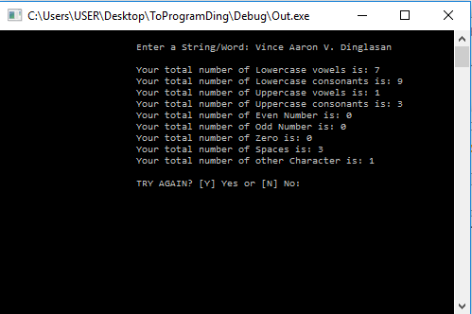

Source Code: Count Upper And LowerCase vowel and consonants, Even and Odd Number

PrimaryMission() {

unit totalV = 0;

unit totalC = 0;

unit totalCC = 0;

unit totalVC = 0;

unit totalNumeven = 0;

unit totalNumodd = 0;

unit totalNumzero = 0;

unit totalSpace = 0;

unit totalCh = 0;

unit length, i;

company sentence;

unit choice=0;

go {

commence;

post("\n\t\t\tEnter a String/Word: ");

capture(#sentence);

length = sentence.Extent;

inquire(i = 0; i < length; i++) {

inorder(sentence[i] = = 'a') {

totalV++;

}

otherorder(sentence[i] = = 'e') {

totalV++;

}

otherorder(sentence[i] = = 'i') {

totalV++;

}

otherorder(sentence[i] = = 'o') {

totalV++;

}

otherorder(sentence[i] = = 'u') {

totalV++;

}

otherorder(sentence[i] = = 'A') {

totalVC++;

}

otherorder(sentence[i] = = 'I') {

totalVC++;

}

otherorder(sentence[i] = = 'E') {

totalVC++;

}

otherorder(sentence[i] = = 'O') {

totalVC++;

}

otherorder(sentence[i] = = 'U') {

totalVC++;

}

otherorder(sentence[i] = = 'b') {

totalC++;

}

otherorder(sentence[i] = = 'c') {

totalC++;

}

otherorder(sentence[i] = = 'd') {

totalC++;

}

otherorder(sentence[i] = = 'f') {

totalC++;

}

otherorder(sentence[i] = = 'g') {

totalC++;

}

otherorder(sentence[i] = = 'h') {

totalC++;

}

otherorder(sentence[i] = = 'j') {

totalC++;

}

otherorder(sentence[i] = = 'k') {

totalC++;

}

otherorder(sentence[i] = = 'l') {

totalC++;

}

otherorder(sentence[i] = = 'm') {

totalC++;

}

otherorder(sentence[i] = = 'n') {

totalC++;

}

otherorder(sentence[i] = = 'p') {

totalC++;

}

otherorder(sentence[i] = = 'q') {

totalC++;

}

otherorder(sentence[i] = = 'r') {

totalC++;

}

otherorder(sentence[i] = = 's') {

totalC++;

}

otherorder(sentence[i] = = 't') {

totalC++;

}

otherorder(sentence[i] = = 'v') {

totalC++;

}

otherorder(sentence[i] = = 'w') {

totalC++;

}

otherorder(sentence[i] = = 'x') {

totalC++;

}

otherorder(sentence[i] = = 'y') {

totalC++;

}

otherorder(sentence[i] = = 'z') {

totalC++;

}

otherorder(sentence[i] = = 'B') {

totalCC++;

}

otherorder(sentence[i] = = 'C') {

totalCC++;

}

otherorder(sentence[i] = = 'D') {

totalCC++;

}

otherorder(sentence[i] = = 'F') {

totalCC++;

}

otherorder(sentence[i] = = 'G') {

totalCC++;

}

otherorder(sentence[i] = = 'H') {

totalCC++;

}

otherorder(sentence[i] = = 'J') {

totalCC++;

}

otherorder(sentence[i] = = 'K') {

totalCC++;

}

otherorder(sentence[i] = = 'L') {

totalCC++;

}

otherorder(sentence[i] = = 'M') {

totalCC++;

}

otherorder(sentence[i] = = 'N') {

totalCC++;

}

otherorder(sentence[i] = = 'P') {

totalCC++;

}

otherorder(sentence[i] = = 'Q') {

totalCC++;

}

otherorder(sentence[i] = = 'R') {

totalCC++;

}

otherorder(sentence[i] = = 'S') {

totalCC++;

}

otherorder(sentence[i] = = 'T') {

totalCC++;

}

otherorder(sentence[i] = = 'V') {

totalCC++;

}

otherorder(sentence[i] = = 'W') {

totalCC++;

}

otherorder(sentence[i] = = 'X') {

totalCC++;

}

otherorder(sentence[i] = = 'Y') {

totalCC++;

}

otherorder(sentence[i] = = 'Z') {

totalCC++;

}

otherorder(sentence[i] = = ' ') {

totalSpace++;

}

otherorder(sentence[i] = = '1') {

totalNumodd++;

}

otherorder(sentence[i] = = '2') {

totalNumeven++;

}

otherorder(sentence[i] = = '3') {

totalNumodd++;

}

otherorder(sentence[i] = = '4') {

totalNumeven++;

}

otherorder(sentence[i] = = '5') {

totalNumodd++;

}

otherorder(sentence[i] = = '6') {

totalNumeven++;

}

otherorder(sentence[i] = = '7') {

totalNumodd++;

}

otherorder(sentence[i] = = '8') {

totalNumeven++;

}

otherorder(sentence[i] = = '9') {

totalNumodd++;

}

otherorder(sentence[i] = = '0') {

totalNumzero++;

}

order {

totalCh++;

}

}

post("\n\t\t\tYour total number of Lowercase vowels is: " + totalV);

post("\n\t\t\tYour total number of Lowercase consonants is: " + totalC);

post("\n\t\t\tYour total number of Uppercase vowels is: " + totalVC);

post("\n\t\t\tYour total number of Uppercase consonants is: " + totalCC);

post("\n\t\t\tYour total number of Even Number is: " + totalNumeven);

post("\n\t\t\tYour total number of Odd Number is: " + totalNumodd);

post("\n\t\t\tYour total number of Zero is: " + totalNumzero);

post("\n\t\t\tYour total number of Spaces is: " + totalSpace);

post("\n\t\t\tYour total number of other Character is: " + totalCh);

go {

company ch;

post("\n\n\t\t\tTRY AGAIN? [Y] Yes or [N] No: ");

capture(#ch);

inorder((ch = = "Y") || (ch = = "y")) {

totalV = 0;

totalVC = 0;

totalC = 0;

totalCC = 0;

totalNumeven =0;

totalNumodd = 0;

totalSpace = 0;

totalCh =0;

length=0;

i=0;

sentence= " ";

choice = 1;

}

otherorder((ch = = "N") || (ch = = "n")) {

choice = 0;

}

order {

post("\n\t\t\tError Input!");

choice = 3;

}

} phase(choice = = 3);

} phase(choice != 0);

post("\n\t\t\tGOODBYE!!");

} deploy();

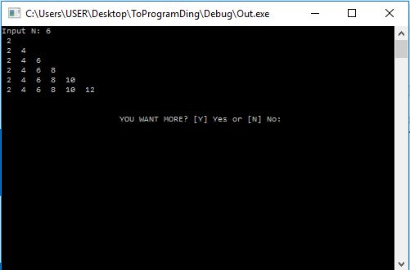Source Code: Even Triangle

PrimaryMission() {

unit i, j,n, num= 2,choice;

go {

commence;

post("Input N: ");

capture(#n);

phase(n<0) {

post("Please Enter a Positive Integer: \n");

capture(#n);

}

inquire(i=0;i<n;i++) {

num=2;

inquire(j=0;j<=i;j++) {

post(" " +num+ " ");

num = num + 2;

}

post("\n");

}

go {

company ch;

post("\n\n\t\t\tYOU WANT MORE? [Y] Yes or [N] No: ");

capture(#ch);

inorder((ch = = "Y") || (ch = = "y")) {

choice = 1;

i=0;

j=0;

n=0;

num=2;

}

otherorder((ch = = "N") || (ch = = "n")) {

choice = 0;

}

order {

post("\n\t\t\tError Input!");

choice = 3;

}

} phase(choice = = 3);

} phase(choice != 0);

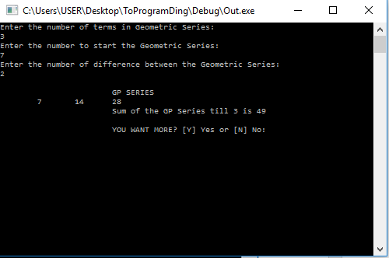post("\n\t\t\t Maraming Salamat Po !!");

} deploy();

Source Code: Geometric Series

unit value;

PrimaryMission() {

unit first,ratio,terms,sum=0, i,choice;

go {

commence;

post("Enter the number of terms in Geometric Series: \n");

capture(#terms);

post("Enter the number to start the Geometric Series: \n");

capture(#first);

post("Enter the number of ratio between the Geometric Series: \n");

capture(#ratio);

value=first;

post("\n\t\t\tGP SERIES \n ");

inquire(i=0;i<terms;i++) {

post("\t" + value + " " );

sum= sum+value;

value = value * ratio;

}

post("\n\t\t\tSum of the GP Series till " +terms+ " is " +sum+ " ");

go {

company ch;

post("\n\n\t\t\tYOU WANT MORE? [Y] Yes or [N] No: ");

capture(#ch);

inorder((ch = = "Y") || (ch = = "y")) {

choice = 1;

first =0;terms=0;ratio=0;value=0;sum=0;

}

otherorder((ch = = "N") || (ch = = "n")) {

choice = 0;

}order {

post("\n\t\t\tError Input!");

choice = 3;

}} phase(choice = = 3);

} phase(choice != 0);

post("\n\t\t\t Maraming Salamat Po !!");

} deploy();

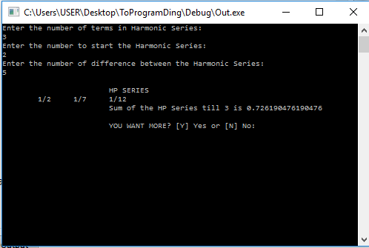

Source Code: Harmonic Series

digit denominator;

digit sum= 0;

PrimaryMission() {

unit first,diff,terms, i,choice;

go {

commence;

post("Enter the number of terms in Harmonic Series: \n");

capture(#terms);

phase(terms<0) {

post("Please Enter a Positive number of terms :\n ");

capture(#terms);

}

post("Enter the number to start the Harmonic Series: \n");

capture(#first);

post("Enter the number of difference between the Harmonic Series: \n");

capture(#diff);

denominator=first;

post("\n\t\t\tHP SERIES \n ");

inquire(i=0;i<terms;i++) {

post("\t1/" + denominator + " " );

sum= sum + 1/denominator;

denominator = denominator + diff;

}

post("\n\t\t\tSum of the HP Series till " +terms+ " is " +sum+ " ");

go {

company ch;

post("\n\n\t\t\tYOU WANT MORE? [Y] Yes or [N] No: ");

capture(#ch);

inorder((ch = = "Y") || (ch = = "y")) {

choice = 1;

first =0;

terms=0;

diff=0;

denominator=0;

sum=0;

}

otherorder((ch = = "N") || (ch = = "n")) {

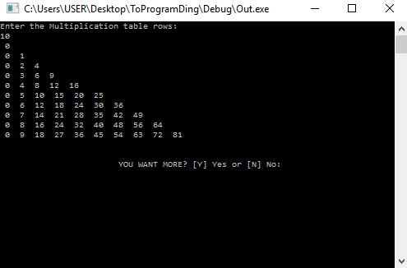choice = 0;

}

order {

post("\n\t\t\tError Input!");

choice = 3;

}

} phase(choice = = 3);

} phase(choice != 0);

post("\n\t\t\t Maraming Salamat Po !!");

} deploy();

Source Code: Multiplication Triangle

PrimaryMission() {

unit i,j,rows,var;

unit count=1;

unit choice;

go {

commence;

post("Enter the Multiplication table rows: \n");

capture(#rows);

phase(rows<0) {

post("Please Enter a Positive number of ROWS!! :\n");

capture(#rows);

}

inquire(i=0;i<rows;i++) {

inquire(j=0;j<=i;j++) {

var = i*j;

post(" " + var + " ");

}

post("\n");

}

go {

company ch;

post("\n\n\t\t\tYOU WANT MORE? [Y] Yes or [N] No: ");

capture(#ch);

inorder((ch = = "Y") || (ch = = "y")) {

choice = 1;

i=0;

j=0;

rows=0;

var=0;

count=1;

}

otherorder((ch = = "N") || (ch = = "n")) {

choice = 0;

}

order {

post("\n\t\t\tError Input!");

choice = 3;

}

} phase(choice = = 3);

} phase(choice != 0);

post("\n\t\t\t Maraming Salamat Po !!");

} deploy();

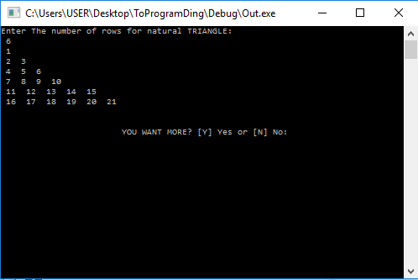

Source Code: Natural Number Triangle

PrimaryMission() {

unit i, j, rows,choice;

unit count =1;

go {

commence;

post("Enter The number of rows for natural TRIANGLE: \n ");

capture(#rows);

phase(rows<0) {

post("Please Enter a Positive number of ROWS!! :\n");

capture(#rows);

}

inquire(i=1;i<=rows;i++) {

inquire(j=1;j<=i;j++) {

post(" " +count+ " ");

count++;

}

post("\n");

}

go {

company ch;

post("\n\n\t\t\tYOU WANT MORE? [Y] Yes or [N] No: ");

capture(#ch);

inorder((ch = = "Y") || (ch = = "y")) {

choice = 1;

i=0;

j=0;

rows=0;

count=1;

}

otherorder((ch = = "N") || (ch = = "n")) {

choice = 0;

}

order {

post("\n\t\t\tError Input!");

choice = 3;

}

} phase(choice = = 3);

} phase(choice != 0);

post("\n\t\t\t Maraming Salamat Po !!");

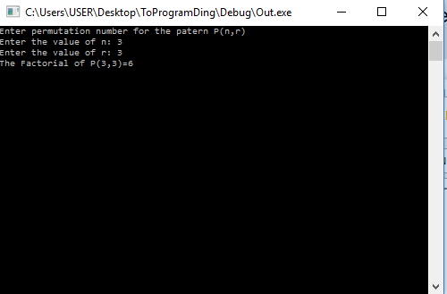} deploy();

Source Code: Permutation

unit fact(unit c) {

unit f=1;

phase(c>0) {

f= f*c;

c--;

} backup(f);

}

PrimaryMission() {

unit p, r, n,v;

post("Enter permutation number for the patern P(n,r) \n");

post("Enter the value of n: ");

capture(#n);

post("Enter the value of r: ");

capture(#r);

p= fact(n) / fact(n-r);

post("The Factorial of P(" +n+ "," +r+ ") =" +p+ " ");

} deploy();

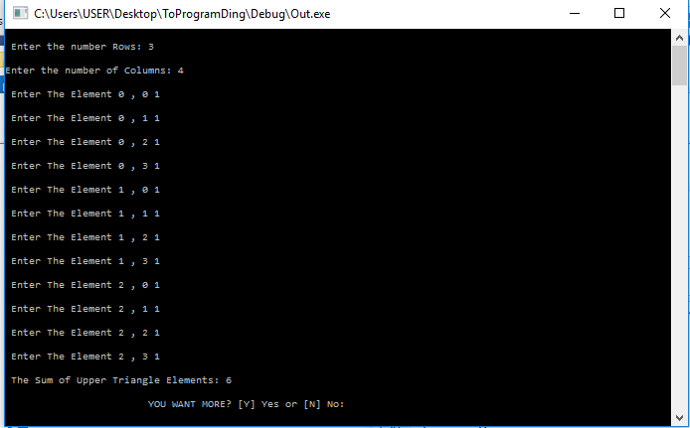

Source Code: Sum of Upper Triangle of a Matrix

unit a[10][10];

unit j;

PrimaryMission() {

unit i, sum, rows, columns,choice;

go {

commence;

post("\n Enter the number Rows: ");

capture(#rows);

post("\nEnter the number of Columns: ");

capture(#columns);

inquire(i=0;i<rows;i++) {

inquire(j=0;j<columns;j++) {

post("\n Enter The Element " + i + " , " +j+ " ");

capture(#a[i][j]);

}

}

sum =0;

inquire(i=0;i<rows;i++) {

inquire(j=0;j<columns;j++) {

inorder(i<j) {

sum = sum + a[i][j];

}

}

}

post("\n The Sum of Upper Triangle Elements: " +sum+ " ");

go {

company ch;

post("\n\n\t\t\tYOU WANT MORE? [Y] Yes or [N] No: ");

capture(#ch);

inorder((ch = = "Y") || (ch = = "y")) {

choice = 1;

i=0;

j=0;

rows=0;

sum=0;

columns=0;

}

otherorder((ch = = "N") || (ch = = "n")) {

choice = 0;

}

order {

post("\n\t\t\tError Input!");

choice = 3;

}

} phase(choice = = 3);

} phase(choice != 0);

post("\n\t\t\t Maraming Salamat Po !!");

} deploy();

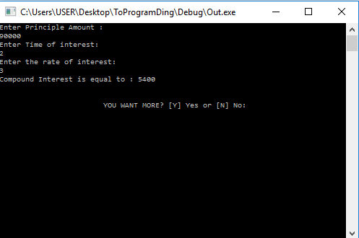Source Code: Compound Interest

PrimaryMission() {

digit principle, rate, C,C2,rated,timed;

unit time,choice;

go {

commence;

post("Enter Principle Amount : \n");

capture(#principle);

post("Enter Time of interest: \n");

capture(#time);

post("Enter the rate of interest: \n");

capture(#rate);

rated= 1 + (rate/100);

timed= rated*time;

C = principle*rated;

C2 = (C-principle) * time;

post("Compound Interest is equal to : " +C2+ "\n");

go {

company ch;

post("\n\n\t\t\tYOU WANT MORE? [Y] Yes or [N] No: ");

capture(#ch);

inorder((ch = = "Y") || (ch = = "y")) {

choice = 1;

principle =0;

rated=0;

C=0;

C2=0;

time=0;

timed=0;

rate=0;

}

otherorder((ch = = "N") || (ch = = "n")) {

choice = 0;

}

order {

post("\n\t\t\tError Input!");

choice = 3;

}

} phase(choice = = 3);

} phase(choice != 0);

post("\n\t\t\t Maraming Salamat Po !!");

} deploy();

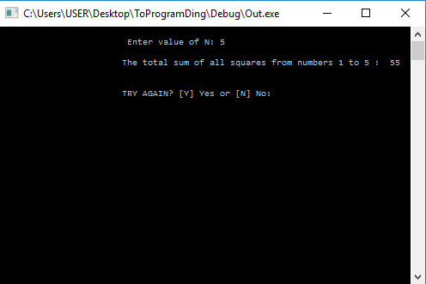

Source Code: Sum of Squares from 1-n

PrimaryMission() {

unit a, no, var,choice, square = 0, sum=0;

go {

commence;

post("\n\t\t\t Enter value of N: " );

capture(#no);

inorder(no>0) {

inquire(a=1;a<=no;a++) {

square=a*a;

sum=sum+square;

}

post("\n\t\t\tThe total sum of all squares from numbers 1 to " + no + " : " + sum + " \n" );

}

order {

inquire(a=1;a>=no;a--) {

square=a*a;

sum=sum+square;

}

post("\n\t\t\tThe total sum of all squares from numbers 1 to " + no + " : " + sum + " \n" );

}

go {

company ch;

post("\n\n\t\t\tTRY AGAIN? [Y] Yes or [N] No: ");

capture(#ch);

inorder((ch = = "Y") || (ch = = "y")) {

no=0;

var=0;

choice = 1;

sum=0;

square=0;

}

otherorder((ch = = "N") || (ch = = "n")) {

choice = 0;

}

order {

post("\n\t\t\tError Input!");

choice = 3;

}

} phase(choice = = 3);

} phase(choice != 0);

post("\n\t\t\tPAALAM HANGGANG SA MULING PAGIINPUT!!");

} deploy();

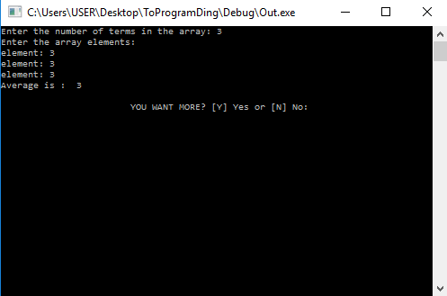Souce Code: Average of set of elements

unit a[100];

PrimaryMission() {

unit m,i,choice;

unit sum= 0;

unit avg= 0;

go {

commence;

post("Enter the number of terms in the array: ");

capture(#m);

phase(m<0) {

post("Enter positive number of terms in the array: ");

capture(#m);

}

a[m] = a[m];

post("Enter the array elements: \n");

inquire(i=0;i<m;i++) {

post("element: ");

capture(#a[i]);

}

inquire(i=0;i<m;i++) {

sum = sum + a[i];

}

avg= sum/m;

post("Average is : " +avg + " ");

go {

company ch;

post("\n\n\t\t\tYOU WANT MORE? [Y] Yes or [N] No: ");

capture(#ch);

inorder((ch = = "Y") || (ch = = "y")) {

choice = 1;

i=0;

m=0;

avg=0;

sum=0;

}

otherorder((ch = = "N") || (ch = = "n")) {

choice = 0;

}

order {

post("\n\t\t\tError Input!");

choice = 3;

}

} phase(choice = = 3);

} phase(choice != 0);

post("\n\t\t\t Maraming Salamat Po !!");

} deploy();

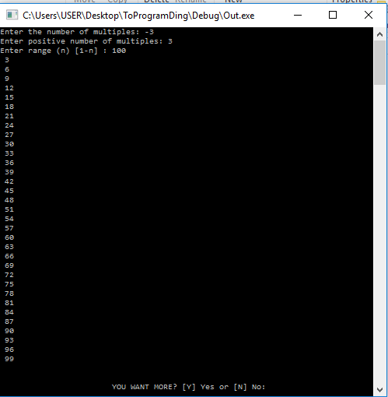

Source Code: Multiples of y in given range

PrimaryMission() {

unit a,i,y,z,choice;

go {

commence;

post("Enter the number of multiples: ");

capture(#y);

phase(y<0) {

post("Enter positive number of multiples: ");

capture(#y);

}

post("Enter range (n) [1-n] : ");

capture(#z);

inorder(z>=1) {

inquire(i=1;i<z;i++) {

a = i % y;

inorder(a = = 0) {

post(" " +i+ "\n");

}

}

}

order {

post("Input value is too low......... : ");

}

go {

company ch;

post("\n\n\t\t\tYOU WANT MORE? [Y] Yes or [N] No: ");

capture(#ch);

inorder((ch = = "Y") || (ch = = "y")) {

choice = 1;

i=0;

a=0;

y=0;

z=0;

}

otherorder((ch = = "N") || (ch = = "n")) {

choice = 0;

}

order {

post("\n\t\t\tError Input!");

choice = 3;

}

} phase(choice = = 3);

} phase(choice != 0);

post("\n\t\t\t Maraming Salamat Po !!");

} deploy();

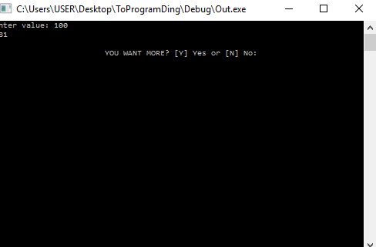

Source Code: Number that don’t contains 3 within the range

unit count(unit n) {

unit m,msd,a,t,b,c,e,f,g,d;

unit po=1;

inorder(n<3) {

backup(n);

}

inorder((n>=3) & (n<10)) {

n= n-1;

backup(n);

}

m= n/po;

phase(m>9) {

po = po * 10;

m= n/po;

}

msd = n/po;

inorder(msd !=3) {

a = count(msd);

t= po-1;

b=count(t);

e= n%po;

f=count(e);

c= a * b + a+ f;

backup(c);

}

order {

d = msd* po -1;

g = count(d);

backup(g);

}

}

PrimaryMission() {

unit m,msd,a,t,b,c,e,f,g,d;

unit ans,val,choice;

unit po=1;

go {

commence;

post("Enter value: ");

capture(#val);

phase(val<0) {

post("Enter positive value: ");

capture(#val);

}

ans = count(val);

post(" " +ans+ " ");

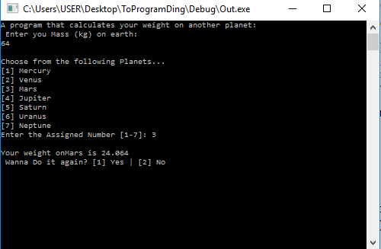

go {

company ch;

post("\n\n\t\t\tYOU WANT MORE? [Y] Yes or [N] No: ");

capture(#ch);

inorder((ch = = "Y") || (ch = = "y")) {

choice = 1;

m=0;

msd=0;

ans=0;

val=0;

a=0;

b=0;

c=0;

d=0;

g=0;

f=0;

t=0;

po=0;

}

otherorder((ch = = "N") || (ch = = "n")) {

choice = 0;

}

order {

post("\n\t\t\tError Input!");

choice = 3;

}

} phase(choice = = 3);

} phase(choice != 0);

post("\n\t\t\t Maraming Salamat Po !!");

} deploy();

Source Code: Gravity converter

PrimaryMission() {

unit earth,nplanet,checker,ans;

unit again=0;

digit weight=0;

company splanet = " ";

go {

post("A program that calculates your weight on another planet:\n ");

post("Enter you Mass (kg) on earth: \n");

go {

capture(#earth);

inorder(earth<=0) {

post("Please dont input zero or negative number, Input again: ");

checker=1;

}

order {

checker =0;

}

} phase(checker= = 1);

post("\nChoose from the following Planets... \n[1] Mercury\n[2] Venus\n[3] Mars\n[4] Jupiter\n[5] Saturn\n[6] Uranus\n[7] Neptune\n");

post("Enter the Assigned Number [1-7]: ");

go {

capture(#nplanet);

inorder(nplanet = = 1) {

weight = earth * 0.38;

splanet = "Mercury";

checker =0;

}

otherorder(nplanet = = 2) {

weight = earth * 0.38;

splanet = "Mercury";

checker =0;

}

otherorder(nplanet = = 2) {

weight = earth * 0.904;

splanet = "Venus";

checker =0;

}

otherorder(nplanet = = 3) {

weight = earth * 0.376;

splanet = "Mars";

checker =0;

}

otherorder(nplanet = = 4) {

weight = earth * 2.53;

splanet = "Jupiter";

checker =0;

}

otherorder(nplanet = = 5) {

weight = earth * 1.07;

splanet = "Saturn";

checker =0;

}

otherorder(nplanet = = 6) {

weight = earth * 0.89;

splanet = "Uranus";

checker =0;

}

otherorder(nplanet = = 2) {

weight = earth * 1.14;

splanet = "Neptune";

checker =0;

}

order {

post("Invalid Input!! - Please Input again: ");

checker=1;

}

} phase(checker==1);

post("\nYour weight on" +splanet+ " is " +weight+ " " );

post("\n Wanna Do it again? [1] Yes | [2] No ");

go {

capture(#ans);

inorder(ans= =1) {

commence;

checker = 0;

again=1;

}

otherorder(ans= =2) {

post("Thanks You ");

checker = 0;

again =0;

}

order {

post("Invalid Input !!! Please Input again: ");

checker = 1;

}

} phase(checker= =1);

} phase(again= =1);

} deploy();

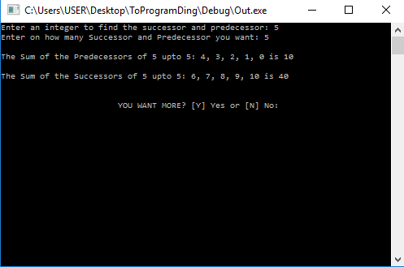

Source Code Predecessor and Successor SUM

unit x,i,n;

digit y,w;

PrimaryMission() {

digit sumy=0;

digit sumw=0;

unit choice;

go {

commence;

post("Enter an integer to find the successor and predecessor: ");

capture(#x);

post("Enter on how many Successor and Predecessor you want: ");

capture(#n);

inorder((x>0) || (x<0)) {

post("\nThe Sum of the Predecessors of " +x+ " upto " + n + ": ");

inquire(i=1;i<=n;i++) {

w = x-i;

post(w + ", " );

sumw = sumw + w;

}

post("\b\b is " + sumw + "\n");

post("\nThe Sum of the Successors of " +x+ " upto " + n + ": ");

inquire(i=1;i<=n;i++) {

y = x+i;

post(y + ", " );

sumy = sumy + y;

}

post("\b\b is " + sumy + "\n");

}

go {

company ch;

post("\n\n\t\t\tYOU WANT MORE? [Y] Yes or [N] No: ");

capture(#ch);

inorder((ch = = "Y") || (ch = = "y")) {

choice = 1;

n=0;

sumy=0;

sumw=0;

x=0;

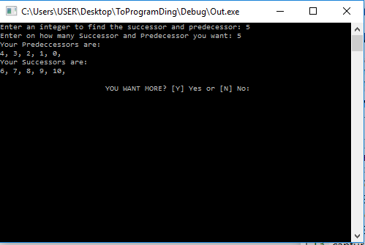

Source Code: Predecessors and Successors

unit x,i,n;

digit y,w;

PrimaryMission() {

digit sumy=0;

digit sumw=0;

unit choice;

go {

commence;

post("Enter an integer to find the successor and predecessor: ");

capture(#x);

post("Enter on how many Successor and Predecessor you want: ");

capture(#n);

inorder((x>0) || (x<0)) {

post("Your Predeccessors are: \n");

inquire(i=1;i<=n;i++) {

w = x-i;

post(w + ", " );

}

post("\nYour Successors are: \n");

inquire(i=1;i<=n;i++) {

y = x+i;

post(y + ", " );

}

}

go {

company ch;

post("\n\n\t\t\tYOU WANT MORE? [Y] Yes or [N] No: ");

capture(#ch);

inorder((ch = = "Y") || (ch = = "y")) {

choice = 1;

n=0;

x=0;

i=0;

w=0;

y=0;

}

otherorder((ch = = "N") || (ch = = "n")) {

choice = 0;

}

order {

post("\n\t\t\tError Input!");

choice = 3;

}

} phase(choice = = 3);

} phase(choice != 0);

post("\n\t\t\t Maraming Salamat Po !!");

} deploy();

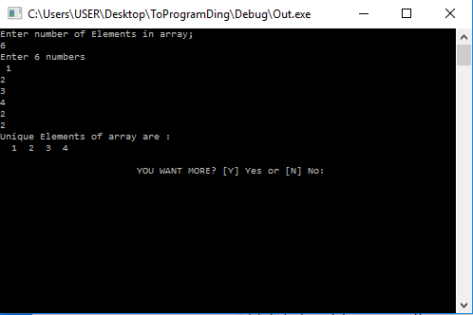

Source Code: Unique Elements

unit array[100];

PrimaryMission() {

unit size, i, j, choice;

go {

commence;

post("Enter number of Elements in array; \n");

capture(#size);

phase(size<0) {

post("Please ENTER A NUMBER Greater than ZERO: ");

capture(#size);

}

post("Enter " +size+ " numbers \n ");

inquire(i=0;i<size;i++) {

capture(#array[i]);

}

post("Unique Elements of array are : \n ");

inquire(i=0;i<size;i++) {

inquire(j=0;j<i;j++) {

inorder(array[i] = = array[j]) {

inorder(i = = j) {

post(" " + array[i] + " ");

}

abort();

}

}

inorder(i = = j) {

post(" " + array[i] + " ");

}

}

go {

company ch;

post("\n\n\t\t\tYOU WANT MORE? [Y] Yes or [N] No: ");

capture(#ch);

inorder((ch = = "Y") || (ch = = "y")) {

choice = 1;

i=0;

j=0;

size=0;

}

otherorder((ch = = "N") || (ch = = "n")) {

choice = 0;

}

order {

post("\n\t\t\tError Input!");

choice = 3;

}

} phase(choice = = 3);

} phase(choice != 0);

post("\n\t\t\t Maraming Salamat Po !!");

} deploy();

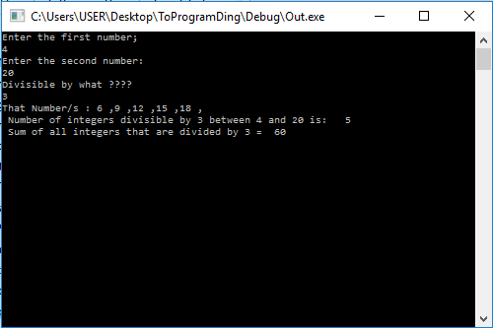

Source Code: Number divisible by n within the range and its sum

PrimaryMission() {

unit i, num1,num2, div, res,choice;

unit count=0;

unit sum=0;

go {

commence;

post("Enter the first number; \n");

capture(#num1);

post("Enter the second number: \n");

capture(#num2);

post("Divisible by what ???? \n");

capture(#div);

inorder((num1>0) & (num2>0)) {

post("That Number/s : ");

inquire(i=num1;i<num2;i++) {

res = i%div;

inorder(res = = 0) {

post(i + " ,");

count = count +1;

sum = sum+i;

}

}

post("\n Number of integers divisible by " + div + " between " +num1+ " and " +num2+ " is: " +count+ " ");

post("\n Sum of all integers that are divided by " + div+ " = " +sum+ " ");

}

order {

post("Invalid Value ");

}

go {

company ch;

post("\n\n\t\t\tYOU WANT MORE? [Y] Yes or [N] No: ");

capture(#ch);

inorder((ch = = "Y") || (ch = = "y")) {

choice = 1;

res=0;

div=0;

i=0;

num1=0;

num2=0;

count=0;

sum=0;

}

otherorder((ch = = "N") || (ch = = "n")) {

choice = 0;

}

order {

post("\n\t\t\tError Input!");

choice = 3;

}

} phase(choice = = 3);

} phase(choice != 0);

post("\n\t\t\t Maraming Salamat Po !!");

} deploy();

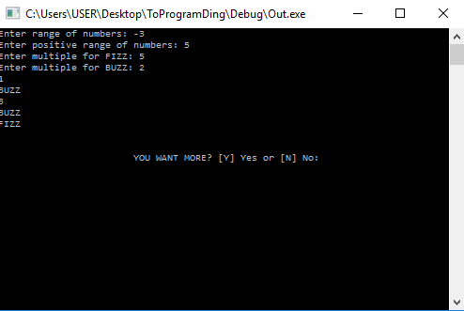

Source Code: BUZZFIZZ

PrimaryMission() {

unit num,i,buzz,fizz,bufsum,fisum,buss,busum;

unit choice;

go {

commence;

post("Enter range of numbers: ");

capture(#num);

phase(num<0) {

post("Enter positive range of numbers: ");

capture(#num);

}

post("Enter multiple for FIZZ: ");

capture(#fizz);

phase(fizz<0) {

post("Enter positive range of numbers: ");

capture(#fizz);

}

post("Enter multiple for BUZZ: ");

capture(#buzz);

phase(buzz<0) {

post("Enter positive range of numbers: ");

capture(#buzz);

}

inquire(i=1;i<=num;i++) {

buss=fizz * buzz;

bufsum=i%buss;

fisum = i%fizz;

busum = i%buzz;

inorder(bufsum= = 0) {

post("BUZZFIZZ\n");

}

otherorder(fisum = =0) {

post("FIZZ\n");

}

otherorder(busum= = 0) {

post("BUZZ\n");

}

order {

post(i + "\n");

}

}

go {

company ch;

post("\n\n\t\t\tYOU WANT MORE? [Y] Yes or [N] No: ");

capture(#ch);

inorder((ch = = "Y") || (ch = = "y")) {

choice = 1;

i=0;

num=0;

buzz=0;

fizz=0;

fisum=0;

buss=0;

busum=0;

bufsum=0;

}

otherorder((ch = = "N") || (ch = = "n")) {

choice = 0;

}

order {

post("\n\t\t\tError Input!");

choice = 3;

}

} phase(choice = = 3);

} phase(choice != 0);

post("\n\t\t\t Maraming Salamat Po !!");

} deploy();

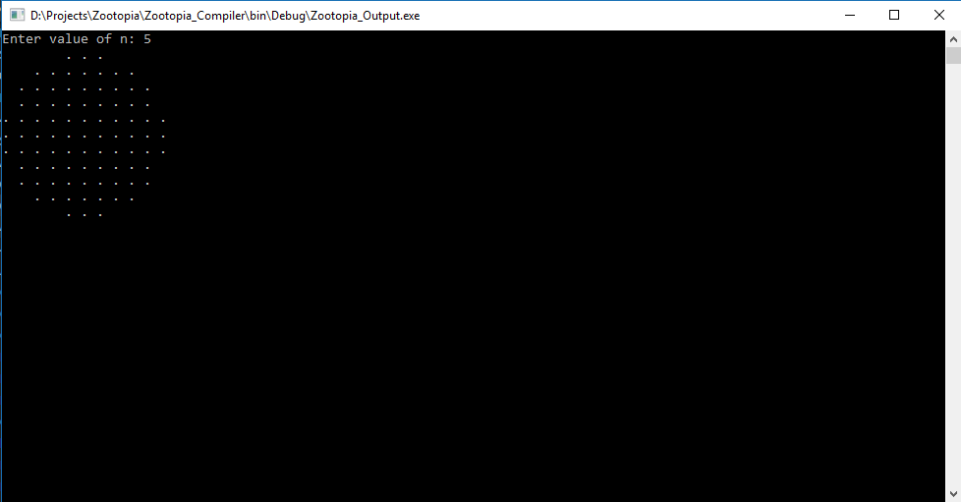

Source code:

Circle without floating point arithmetic

unit r;

PrimaryMission() {

unit a,c,i,j,n,x,y;

unit choice;

go {

commence;

post("Enter value of N: ");

capture(#n);

inorder(n>0) {

n = 2 * r +1;

inquire(i=0;i<n;i++) {

inquire(j=0;j<n;j++) {

x =i -r;

y = j-r;

a = x * x + y * y;

c = r*r+1;

inorder(a<=c) {

post(".");

}

order {

post("* ");

}

post("");

}

post("\n");

}

}

order {

post("INVALID!!!! " );

} go {

company ch;

post("\n\n\t\t\tYOU WANT MORE? [Y] Yes or [N] No: ");

capture(#ch);

inorder((ch = = "Y") || (ch = = "y")) {

choice = 1;

a=0;

c=0;

i=0;

j=0;

n=0;

x=0;

y=0;

r=0;

}

otherorder((ch = = "N") || (ch = = "n")) {

choice = 0;

}

order {

post("\n\t\t\tError Input!");

choice = 3;

}

} phase(choice = = 3);

} phase(choice != 0);

post("\n\t\t\t Maraming Salamat Po !!");

} deploy();